Arjun Arvind Gahane (25070521135)
Exp 15.1
Algorithm:
Step 1: Define the Blueprint (Base Class)
- Create a class named Car.
- Initialize it with four parameters: brand, price, model, and color.
- Store these parameters as instance variables so every car object knows its own data.
Step 2: Establish Inheritance (Derived Classes)
- Create two new classes, Car1 and Car2.
- Link them to the Car class. This ensures they "inherit" the ability to store the brand, price, model, and color without needing new code to handle that data.
Step 3: Implement Method Overriding
- Inside Car1, define a method display_details().
- Inside Car2, define a method display_details().
- Even though they have the same name, each method is responsible for printing its specific object's data in the required four-line format.
Step 4: Receive and Parse Input
- Read the first line of raw input from the user.
- Split that string into a list of four separate items.
- Convert the "price" item into a float (numeric) type.
Step 5: Object Instantiation
- Pass the first set of data into Car1 to create an "instance" (a specific car object).
- Repeat the process for the second line of input to create an instance of Car2.
Step 6: Output Generation
- Trigger the display_details() method for the first car.
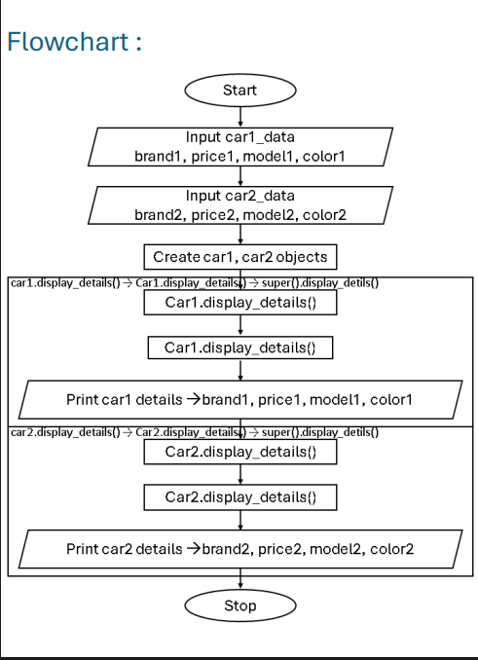

Code: